

User Manual
For:
To provide a comprehensive User Manual that enhances users' understanding of their roles and responsibilities within the DSUITE Application.

Submitted By:
Table of Contents
1 Scope of Documentation 3
2 Overview of DSuite Platform 3
3 DSuite AI Assistant 3
4 Logging In 4
4.1 Login Using Username and Password 5
4.2 Login Using Azure AD / Entra ID 5
4.3 Resetting Your Password 5
5 Project Creation 6
6 Requirement Ingestion and Analysis 7
6.1 Purpose 7
6.2 Supported Input Methods 7
6.3 AI Requirement Analysis 7
7 Governance Evaluation 8
7.1 Purpose of Governance Evaluation 8
7.2 Performing a Governance Assessment 8
7.3 Governance Classifications 9
8 Agent Analysis 10
8.1 Reviewing the Master Note 10
8.2 Reviewing Technical Specifications 10
9 Prerequisite Configuration 11
9.1 Configure AI Rules 11
9.2 Configure Git Repository 11
9.3 Select Execution Mode 12
10 Task Creation 14
11 Resource Onboarding 15
11.1 Adding Resources 15
11.2 Resource Allocation Types 15
12 Status Dashboard 16
12.1 Dashboard Modes 16
13 Administration Page 18
13.1 Role Management 18
13.2 User Management 19
13.3 SSO Configuration 19
14 Bring Your Own Tools (BYOT) 20
15 Conclusion 21

Table of Figures
Figure 1 AI Assistant bot 4
Figure 2 User Login 5
Figure 3 Forgot Password 6
Figure 4 Project Creation 7
Figure 5 Requirement Analysis 8
Figure 6 Governance section 9
Figure 7 Governance Classification 10
Figure 8 Agent Analysis 11
Figure 9 Prerequisites Classification 13
Figure 10 Task Creation 14
Figure 11 Resource Onboarding 15
Figure 12 Project status dashboard 17
Figure 13 Roles and Invites 18
Figure 14 SSO Configuration 19
Figure 14 Bring your Own Tools 20

Scope of Documentation
This User Manual is designed to help business users, developers, project managers, solution architects, QA teams, and administrators effectively use the DSuite platform throughout the complete software delivery lifecycle.
The document provides detailed guidance on:
- Project creation and management
- Governance evaluation and risk assessment
- Requirement ingestion and AI-powered analysis
- Technical specification generation
- Task and sprint generation
- AI agent orchestration
- Resource onboarding and allocation
- Deployment preview management
- Administrative controls and plugin integrations
This manual is intended for all authorized users of the DSuite platform and serves as a comprehensive operational guide for understanding workflows, configurations, and execution processes within the system.
By following this manual, users will be able to efficiently manage AI-assisted software development projects, streamline collaboration, improve governance compliance, and accelerate delivery timelines.

Overview of DSuite Platform
DSuite is an AI-powered software delivery orchestration platform designed to automate and accelerate the end-to-end application development lifecycle.
The platform transforms business requirements into structured technical outputs using intelligent AI agents and workflow automation.
DSuite enables organizations to:
- Upload and analyze business requirements
- Generate technical specifications automatically
- Create development tasks and sprint plans
- Execute AI-assisted coding workflows
- Manage governance and compliance
- Configure repositories and deployment pipelines
- Monitor execution progress in real time
- Preview generated applications instantly
The platform supports multiple execution approaches ranging from developer-led workflows to fully AI-assisted development models.

DSuite AI Assistant
DSuite includes a built-in intelligent AI Assistant that is accessible from every page within the application.
The assistant is fully aware of the current page context, workflow stage, and available features, enabling users to receive immediate assistance without leaving their workspace.
Key Capabilities of the AI Assistant
The assistant can help users with:
- Understanding platform features
- Navigating to specific sections
- Explaining governance rules
- Assisting with configuration steps
- Troubleshooting execution issues
- Explaining AI-generated outputs
- Providing workflow recommendations
- Guiding repository setup and deployment processes
Accessing the Assistant
- Locate the AI Assistant icon within the platform interface.
- Click the assistant icon.
- Enter your question or request.
- Review the generated guidance or recommendations.
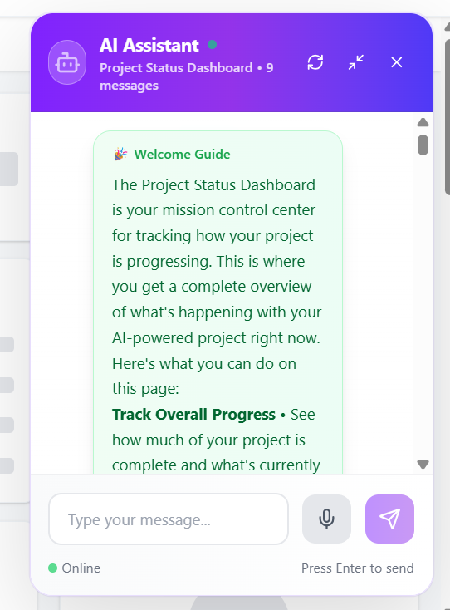
Figure 1 AI Assistant bot

Logging In
- Accessing the DSuite Platform.
- Open the DSuite application URL in your browser.
- The login page will be displayed.
DSuite supports multiple authentication methods. After signing in successfully, the user can proceed to the dashboard and begin working with projects in the next section.

Login Using Username and Password
- Enter your registered username.
- Enter your password.
- Click the Login button.
After successful authentication, you will be redirected to the DSuite dashboard.
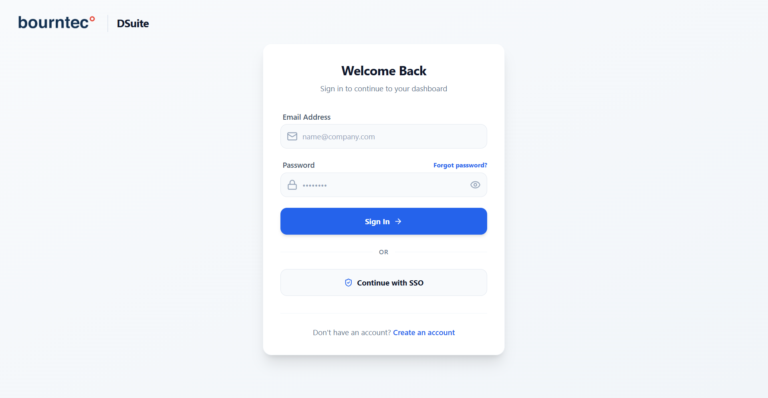
Figure 2 User Login

Login Using Azure AD / Entra ID
- Click Login with Azure AD.
- Authenticate using your organizational Microsoft account.
- Complete multi-factor authentication if prompted.
- After successful verification, you will automatically return to DSuite.
This method enables enterprise-grade Single Sign-On (SSO) authentication.

Resetting Your Password
If you forget your password:
- Click Forgot Password.
- Enter your registered email address.
- Submit the request.
- Follow the password reset instructions received via email.

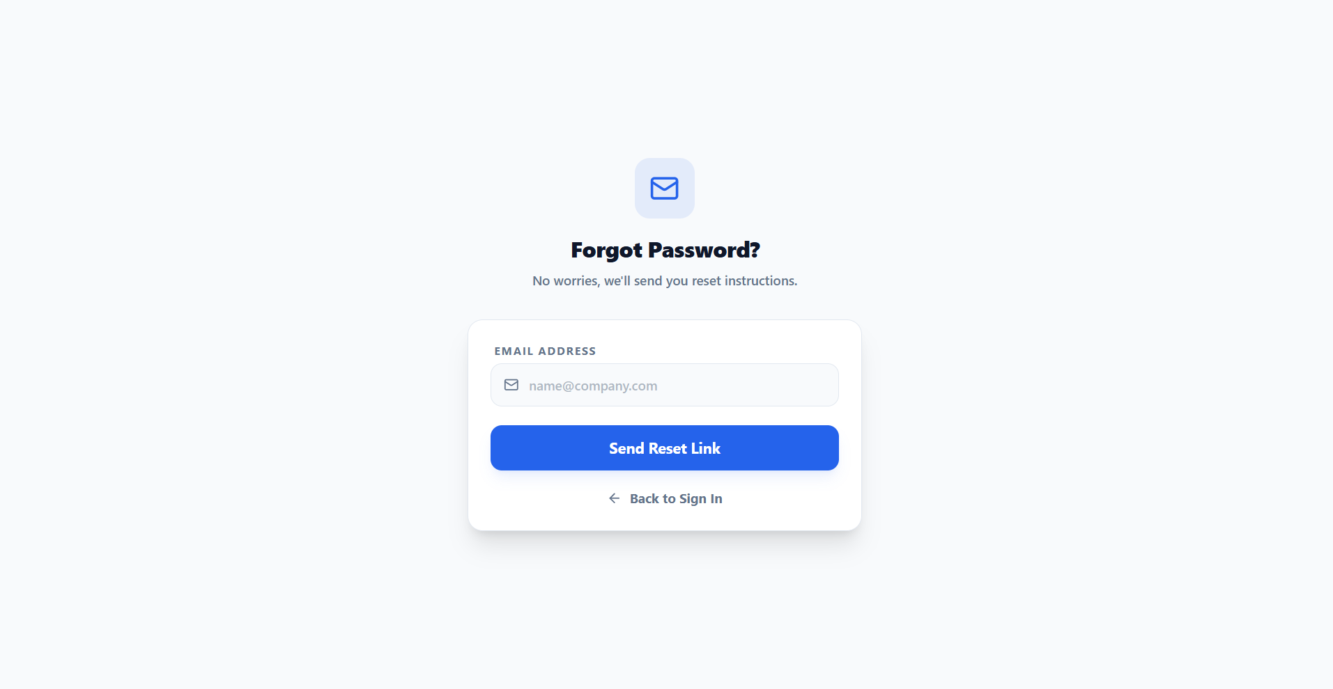
Figure 3 Forgot Password

Project Creation
After logging in and reaching the dashboard, the user should access the Projects module to create, open, or select the project that will be used for the remaining workflow steps.
- Accessing Projects
- Open the navigation menu.
- Select Projects.
- Choose an existing project from the project selector.
Once the appropriate project has been selected, the user can continue to the Requirement Screening section to provide the business requirements that drive all downstream analysis and execution.

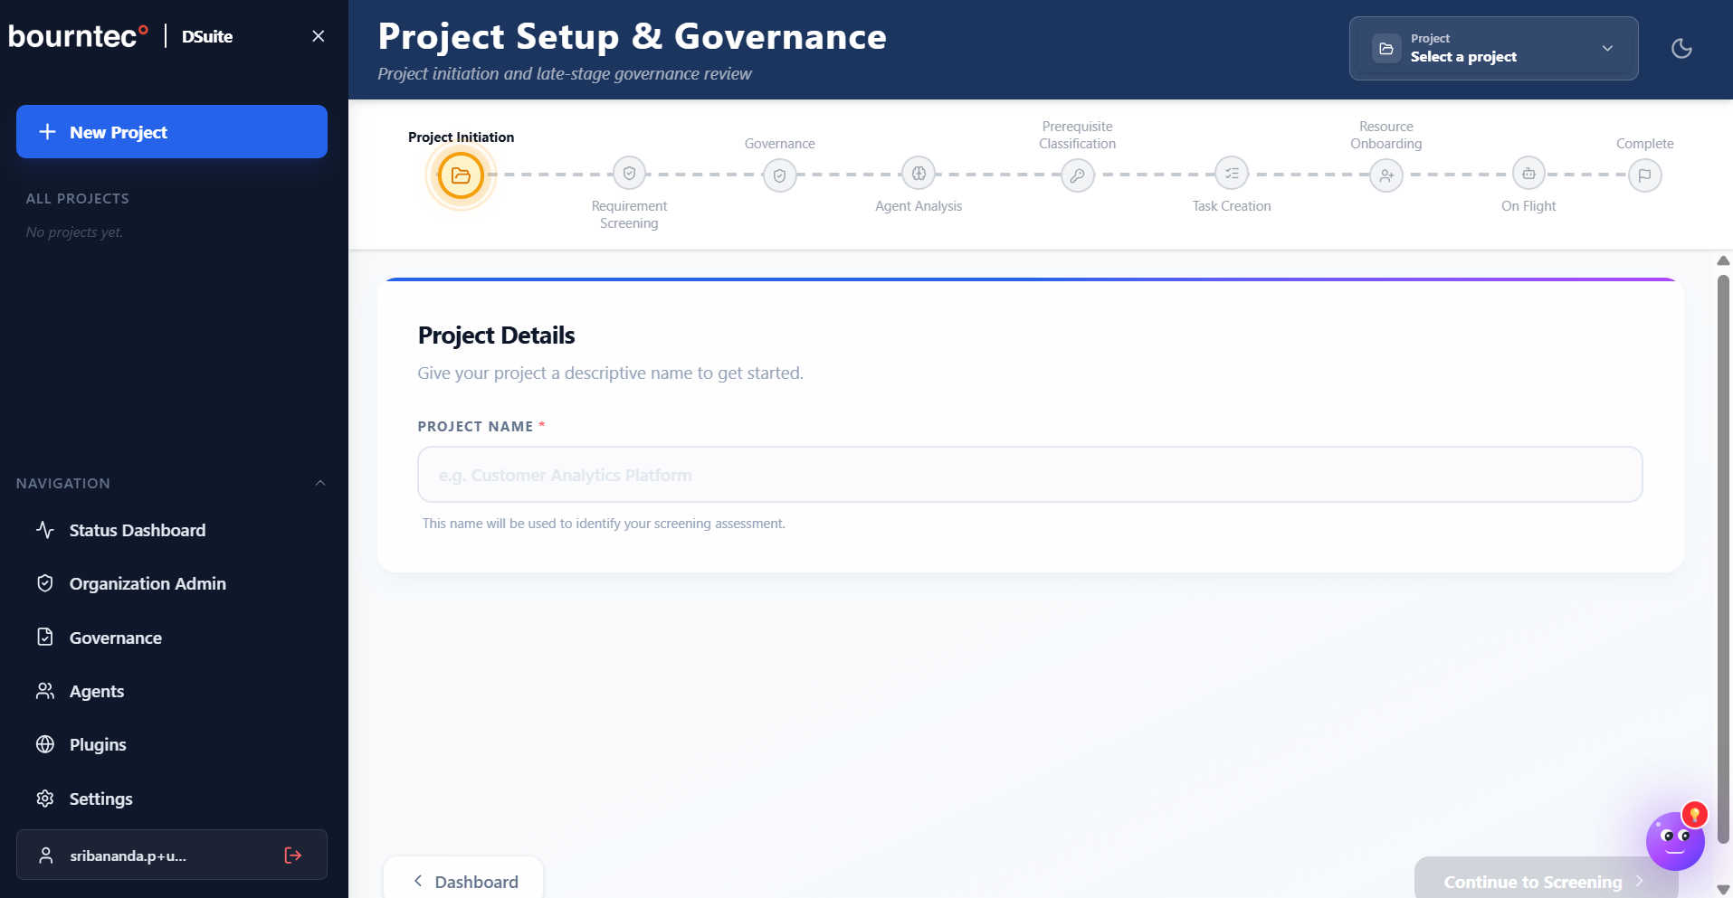
Figure 4 Project Creation

Requirement Ingestion and Analysis

Purpose
After the project is created or selected, the user should navigate to the Requirement Screening section. This section enables the user to upload, connect, or enter business requirements for AI-powered analysis.
DSuite converts raw requirement content into structured technical and functional outputs.
- Uploading Requirements
- Open the selected project.
- Navigate to Requirement Screening.
- Choose one of the available input methods.

Supported Input Methods
Upload Document
Upload BRDs, requirement documents, PDFs, or specifications.
Enter Text
Directly paste requirement content into the editor.
Provide URL
Supply a webpage or hosted document URL.
Connect Repository
Connect source repositories for automated requirement extraction.
Optional Skills Upload
Users can additionally upload:
- skills.md
- methods.md

AI Requirement Analysis
After ingestion, DSuite automatically:
- Extracts business requirements
- Identifies entities and workflows
- Detects technical dependencies
- Generates structured requirement summaries
- Creates AI-readable project context
The analyzed data becomes the foundation for downstream AI processing. After reviewing the requirement analysis, the user should continue to the Governance Evaluation section to assess project risk and compliance before development proceeds.
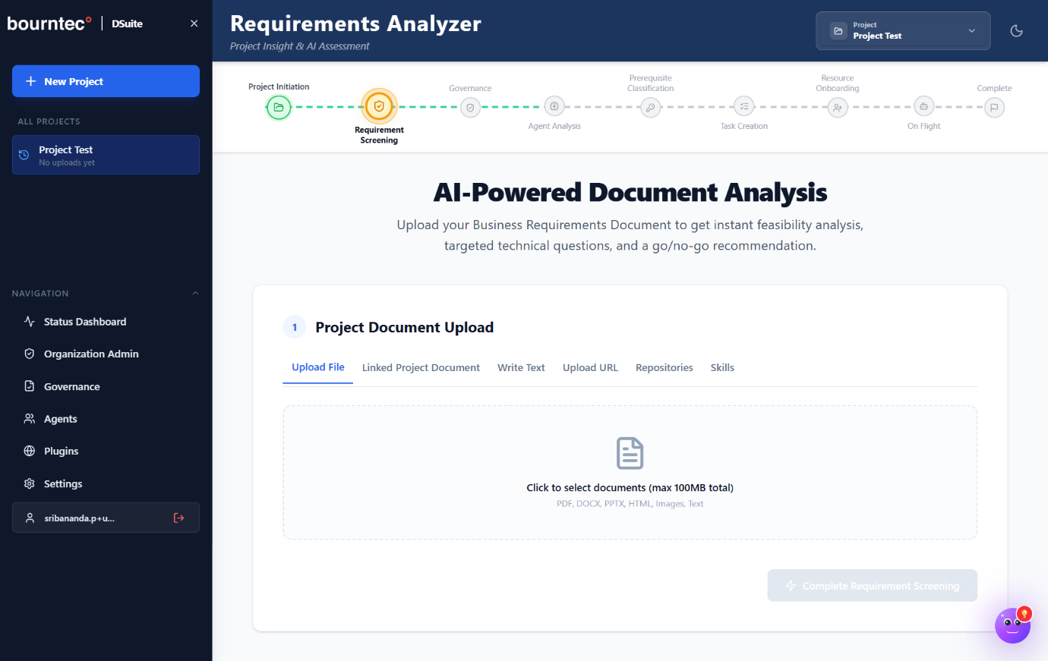
Figure 5 Requirement Analysis

Governance Evaluation

Purpose of Governance Evaluation
The Governance section is used to assess project risk, compliance impact, and operational classification before development activities begin.
This helps organizations enforce governance standards and determine the appropriate execution model for the project. Once the governance assessment is complete and the classification is confirmed, the user can move to Agent Analysis to review the AI-generated understanding of the project.

Performing a Governance Assessment
- Open the Governance section.
- Complete all governance-related questions.
- Review the calculated governance score.
- Submit the assessment for classification.
The system automatically determines the project risk category based on responses.
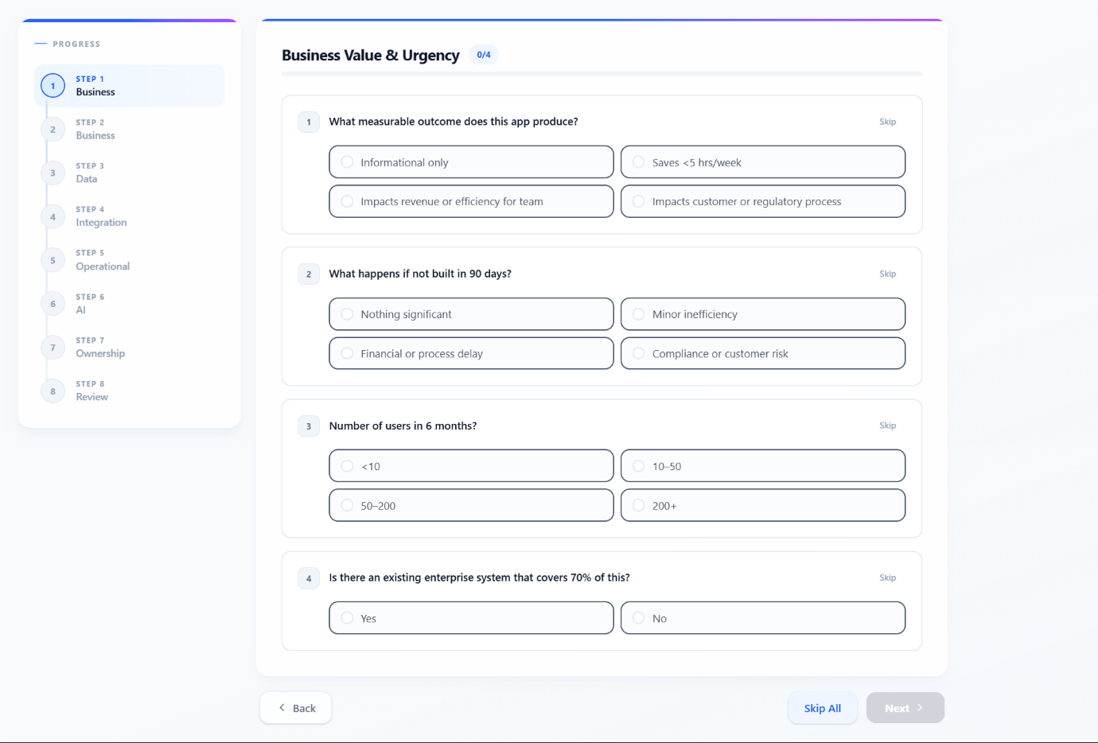
Figure 6 Governance section

Governance Classifications
Sandbox – Low Risk
Used for experimental or low-impact projects with minimal operational exposure.
Controlled Sandbox – Medium Risk
Used for projects requiring moderate governance oversight and operational controls.
Enterprise – High Risk
Used for business-critical applications requiring strict compliance, auditing, and governance policies.
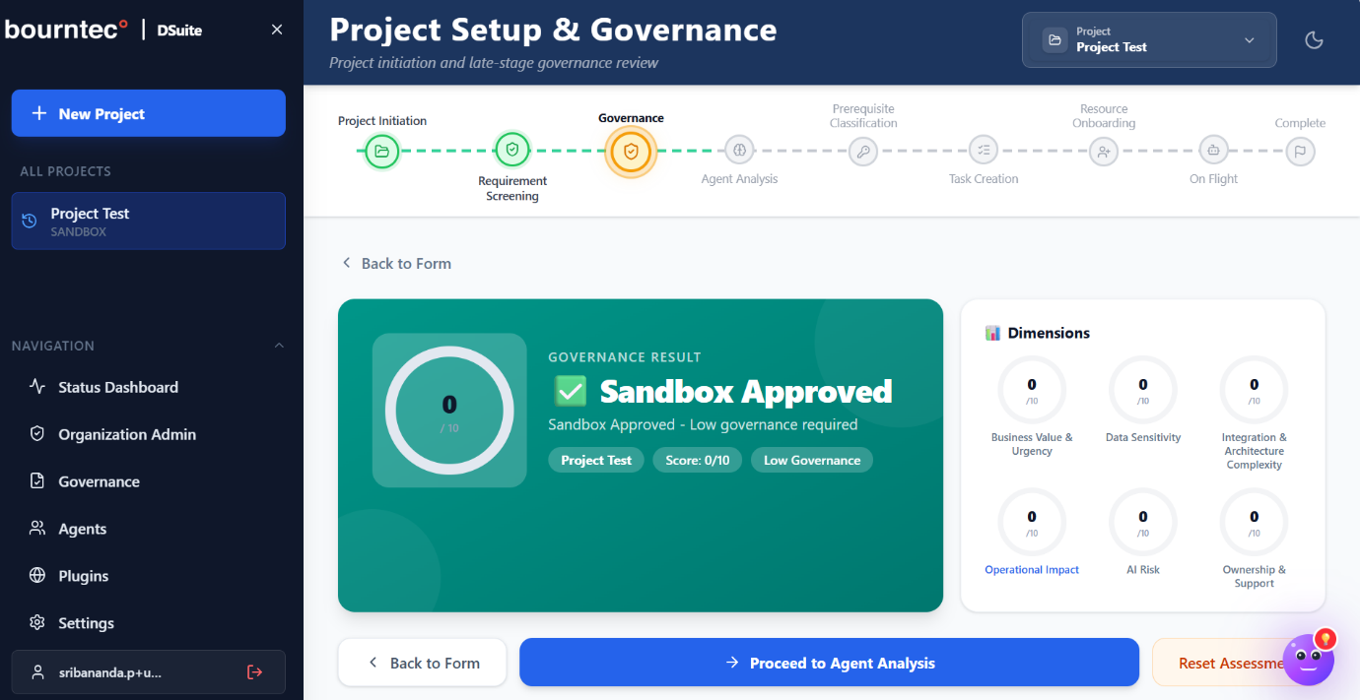
Figure 7 Governance Classification

Agent Analysis
After governance evaluation is completed, the user should open the Agent Analysis section to review the AI-generated technical interpretation of the uploaded requirements.

Reviewing the Master Note
The Master Note serves as the consolidated AI-generated project understanding.
Steps
- Open Agent Analysis.
- Review the generated Master Note.
- Validate:
- Functional understanding
- Workflow mapping
- Project structure
- Business objectives
- Functional understanding
- Workflow mapping
- Project structure
- Business objectives
This serves as the central AI knowledge context for downstream processing.

Reviewing Technical Specifications
DSuite automatically generates technical specifications from analyzed requirements.
Review Areas
- Application architecture
- Technical dependencies
- Service relationships
- API considerations
- Data structures
- Knowledge graph relationships
Users should validate the generated specifications before proceeding. After this review is complete, the next step is to open Prerequisite Configuration and define the rules, repository settings, and execution mode required for implementation.
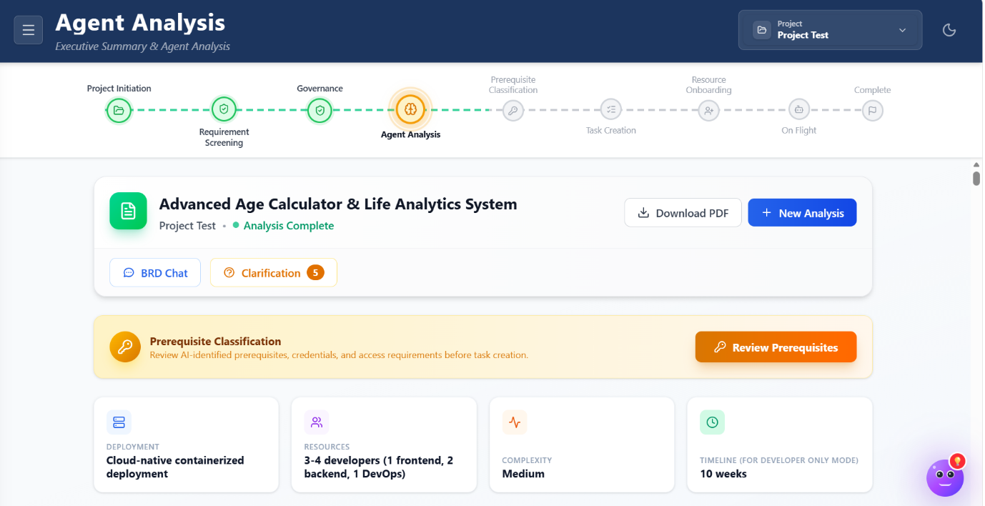
Figure 8 Agent Analysis

Prerequisite Configuration
After reviewing the agent-generated outputs, the user should open the Prerequisite Configuration area to configure execution behavior, repository integrations, and project-specific rules.

Configure AI Rules
Custom AI instructions can be defined to influence agent behavior.
Steps
- Open Prerequisite Configuration.
- Select Custom Rules.
- Enter project-specific AI instructions.
- Save the configuration.

Configure Git Repository
Repository integration enables DSuite to synchronize development workflows.
Steps
- Enter the Repository URL.
- Select the target branch.
- Provide the Personal Access Token (PAT).
- Save repository settings.

The DSuite Platform Supports these repositories:
- GitHub
- Azure DevOps
- GitLab

Select Execution Mode
DSuite supports multiple development execution models.
Developer Only
Traditional developer-led implementation.
AI Assist
AI agents assist developers during implementation.
Vibe Coding
AI-driven collaborative development workflow optimized for rapid prototyping and execution.
Coexistence
Balanced collaboration between developers and AI agents.
AI-First Mode
Maximum AI-driven execution with minimal manual intervention.
The selected mode determines how AI agents participate in project execution. Once these prerequisites are configured, the user can continue to Task Creation to generate executable work items for delivery.
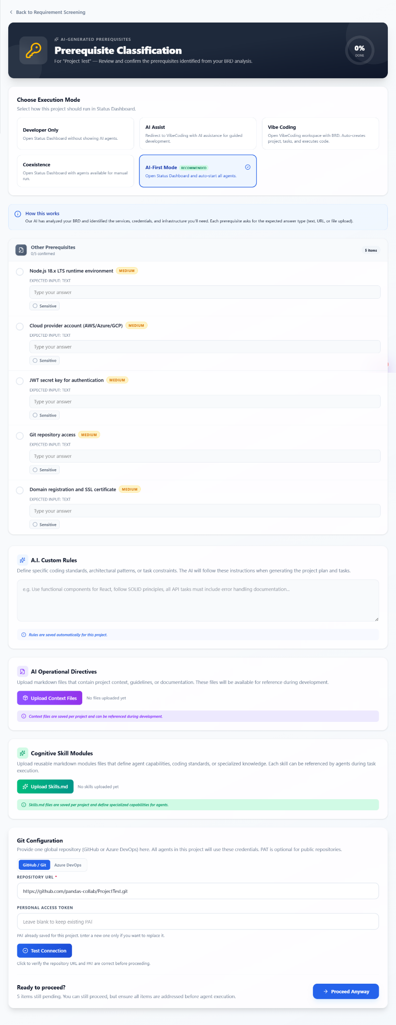
Figure 9 Prerequisites Classification

Task Creation
After prerequisite settings have been saved, the user should open the Task Creation section to convert analyzed requirements into structured implementation tasks and sprint plans.
Generating Tasks
- Open Task Creation.
- Click Auto-Generate Tasks.
- Review generated:
  - Tasks
  - Sprints
  - Milestones
  - Priorities
  - Target dates
- Validate generated outputs.
- Click Start Process.
The AI engine automatically organizes tasks into executable delivery plans. After the tasks are reviewed and initiated, the user can proceed to Resource Onboarding to assign team members and define execution permissions.
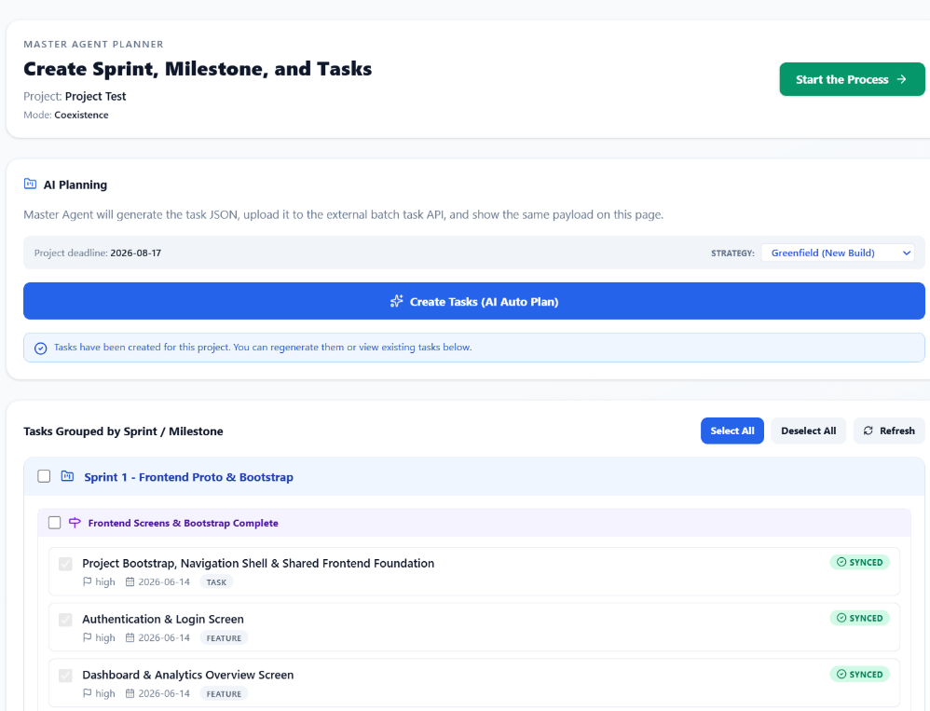
Figure 10 Task Creation

Resource Onboarding
After task generation is complete, the user should open the Resource Onboarding area to assign project members and configure execution permissions.

Adding Resources
- Open Resource Onboarding.
- Add or assign project members.
- Configure Git credentials if required.
- Select agent allocation types.

Resource Allocation Types
Resources may be configured for:
- Development activities
- AI collaboration
- Review workflows
- Repository management
- Deployment execution
Proper onboarding ensures seamless collaboration between human users and AI agents. Once resources are configured, the user can move to the Status Dashboard to monitor progress and track delivery execution.
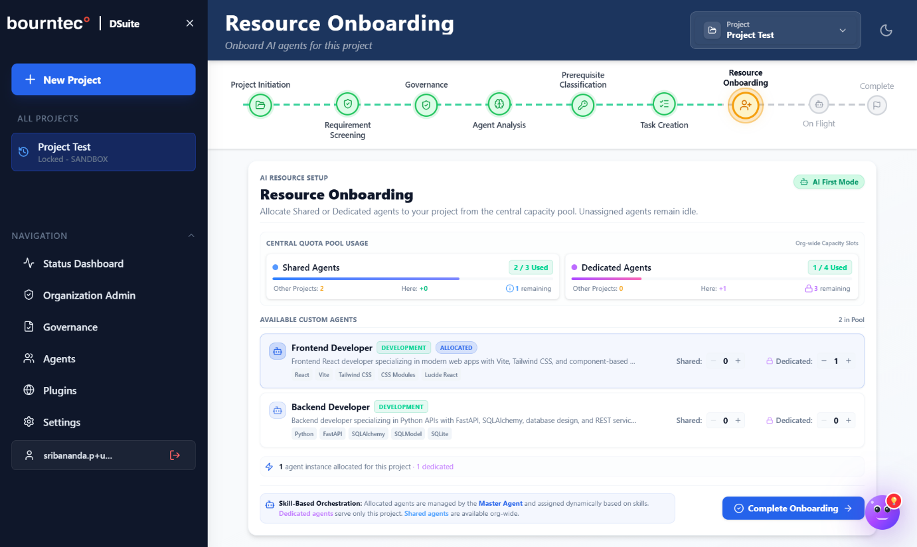
Figure 11 Resource Onboarding

Status Dashboard
After resources have been onboarded, the user should use the Status Dashboard to gain centralized visibility into project execution and delivery progress.
Viewing Project Progress
- Open Status Dashboard.
- Review:
  - Sprint completion
  - Project roadmap
  - Milestone tracking
  - Task status
  - Delayed activities
  - Sprint completion
  - Project roadmap
  - Milestone tracking
  - Task status
  - Delayed activities

Dashboard Modes
Executive Dashboard
Provides high-level KPIs and strategic project health indicators.
Project Dashboard
Provides detailed operational and execution-level metrics.
Key Metrics Available
- Sprint progress
- Completion percentages
- Active tasks
- Upcoming deliverables
- Overdue items
- Agent execution status
- Resource utilization
If additional organization-level setup is required, the user can then continue to the Administration Page to manage roles, users, and authentication settings.
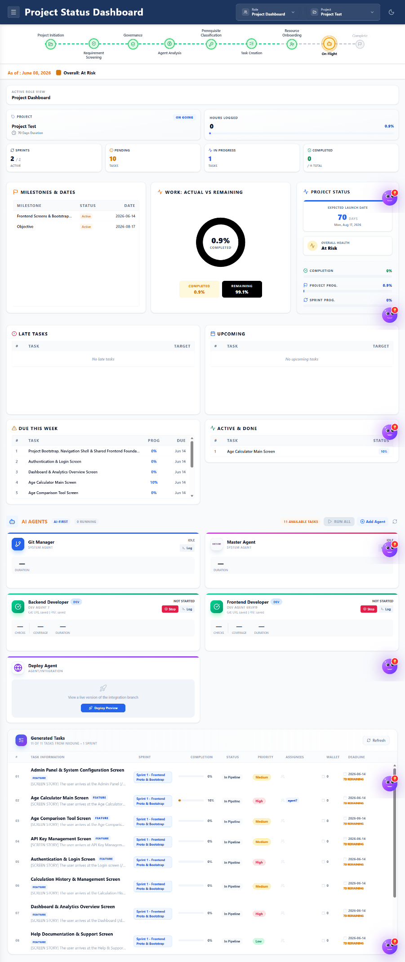
Figure 12 Project status dashboard

Administration Page
If the workflow requires organization-level configuration, the user should open the Administration page to manage roles, users, and enterprise settings.

Role Management
Administrators can create and manage user roles.
Steps
- Open Organization Administration.
- Select Roles.
- Create or modify roles.
- Configure permissions and access levels.
Role-based access control ensures secure platform governance.
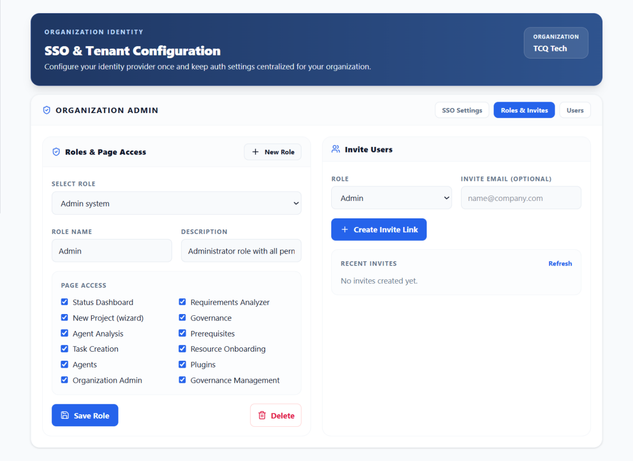
Figure 13 Roles and Invites

User Management
Administrators can invite and manage users.
Steps
- Open Invitations.
- Send user invitations.
- Monitor invitation status.
Users receive onboarding instructions through email.

SSO Configuration
Single Sign-On integration can be configured using Microsoft Entra ID.
Steps
- Open SSO Settings.
- Configure:
  - Client ID
  - Tenant ID
  - Client Secret
- Save configuration settings.
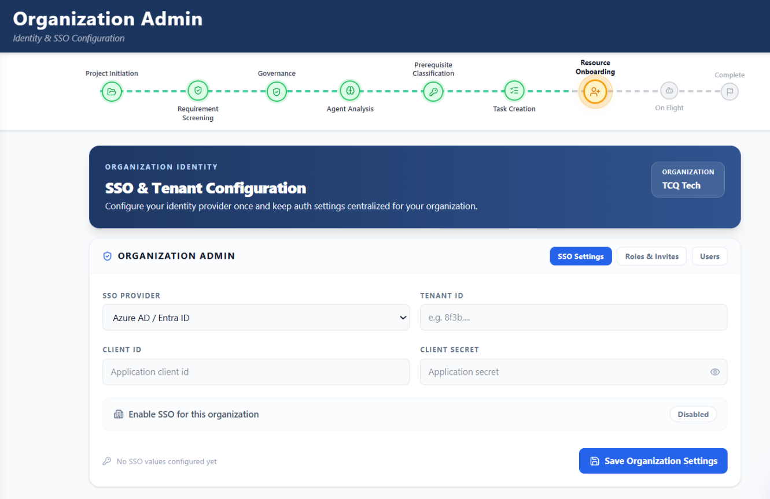
Figure 14 SSO Configuration

Bring Your Own Tools (BYOT)
After completing the required administration settings, the user can open the Bring Your Own Tools (BYOT) section to integrate external platforms and enterprise tools into the project workflow.
Supported Integrations
- NXDUNE
- Jira
- GitHub
- Azure DevOps
- Kaktox
- CloudSPX
Configuring Integrations
- Open Plugins.
- Select the required integration.
- Enter authentication credentials.
- Test the connection.
- Save configuration settings.
Successful integration enables synchronized workflows across connected systems. After completing these optional integrations, the user can refer to the Conclusion section for a final summary of the platform workflow.
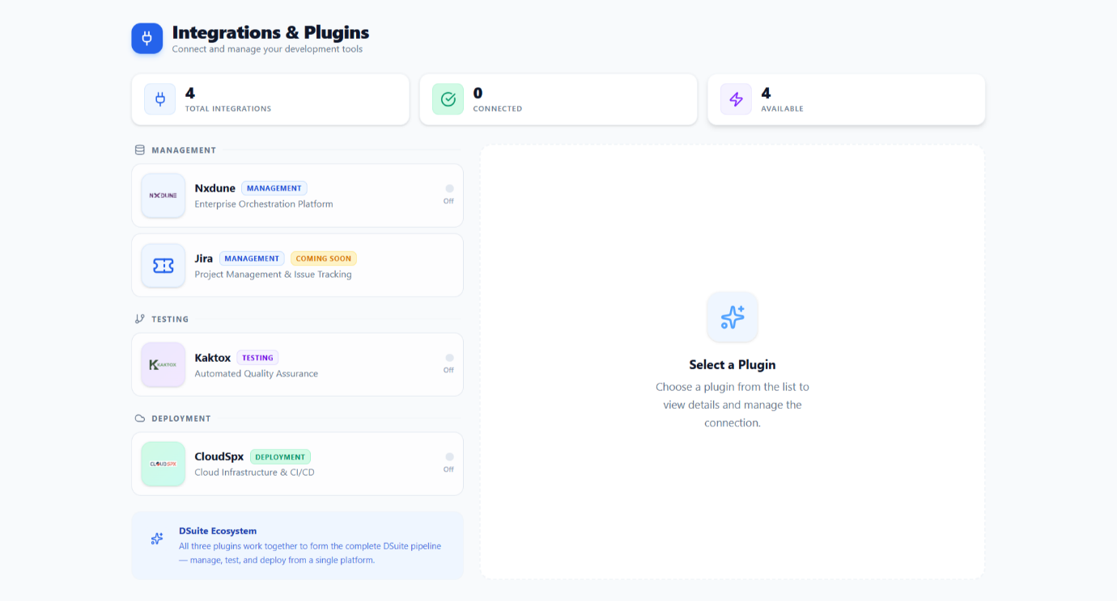
Figure 14 Bring your Own Tools

Conclusion
DSuite provides a unified AI-powered platform that streamlines the complete software delivery lifecycle from requirement analysis and governance assessment to task generation, AI-assisted development, and deployment preview management.

By combining intelligent automation, governance controls, repository integration, and AI agent orchestration, DSuite helps organizations improve collaboration, accelerate development timelines, reduce manual effort, and enhance project visibility.

The platform’s flexible execution models and enterprise-grade administrative capabilities enable teams to adapt DSuite according to their operational needs while maintaining compliance, scalability, and delivery efficiency.

By following the processes and best practices outlined in this manual, users can effectively leverage DSuite to optimize software development workflows and drive faster, more efficient project execution.

